Day 38: 08-12-2025

Props : is a type of variable which help to pass the value from one component to another components. Props is immutable, ie can’t be change. Help to share the data.
<Parent> admin admin@gmail.com
<Child1></Child1> user1 - raj@gmail.com
<Child2></Child2> user2- ravi@gamil.com
</Parent>
- Pass the value from parent to child props
- Pass the value from child1/child2 to parent props with callback concept.
- Share the data between sibling component child1 need to pass the value top parent props with callback and parent pass the value to child2 using props.

npm create vite@latest component-communication

passing value from parent to child using props syntax

<ComponentName key1=value1 key2=value2></ComponentName>

Value can be static or dynamic of type number, string, object, array object, or function etc.

AddData
DisplayData

Consume rest api in react JS
- Fetch() function : which help to consume rest api develop using any language.
- Axios : it is a third party library which internally fetch concept consume rest api. Axios help to handle error message in proper way as well as it provided http method like get, post ,put and patch to handle end point in react js.
npm create vite@latest react-rest-api

after project inside a project you need to install third party dependencies
npm install axios

https://start.spring.io/

Eureka server
Starter web, eureka server

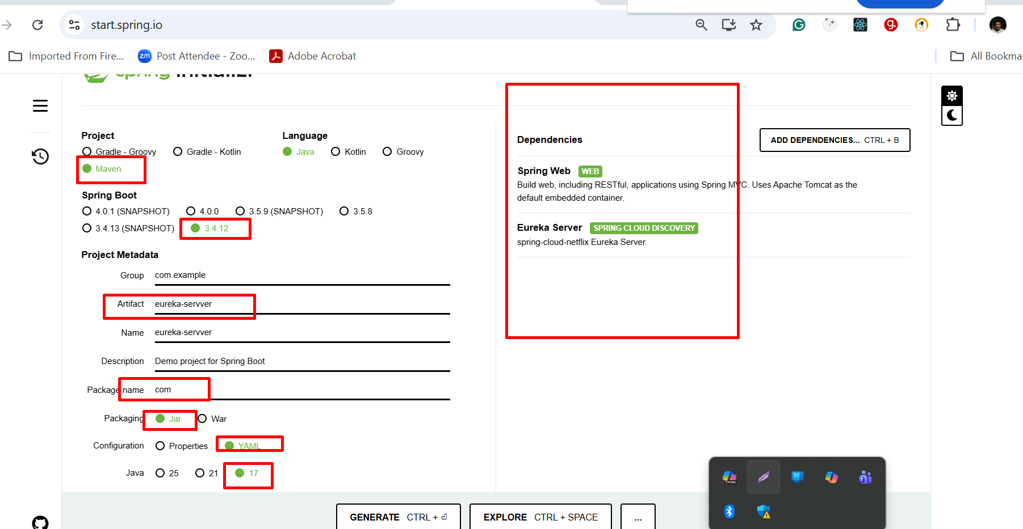

Product-micro service
backend - product-rest-api-backend
starter - web starter, mongo db , discovery client etc

application.prorerties or application.yml (provide details details)

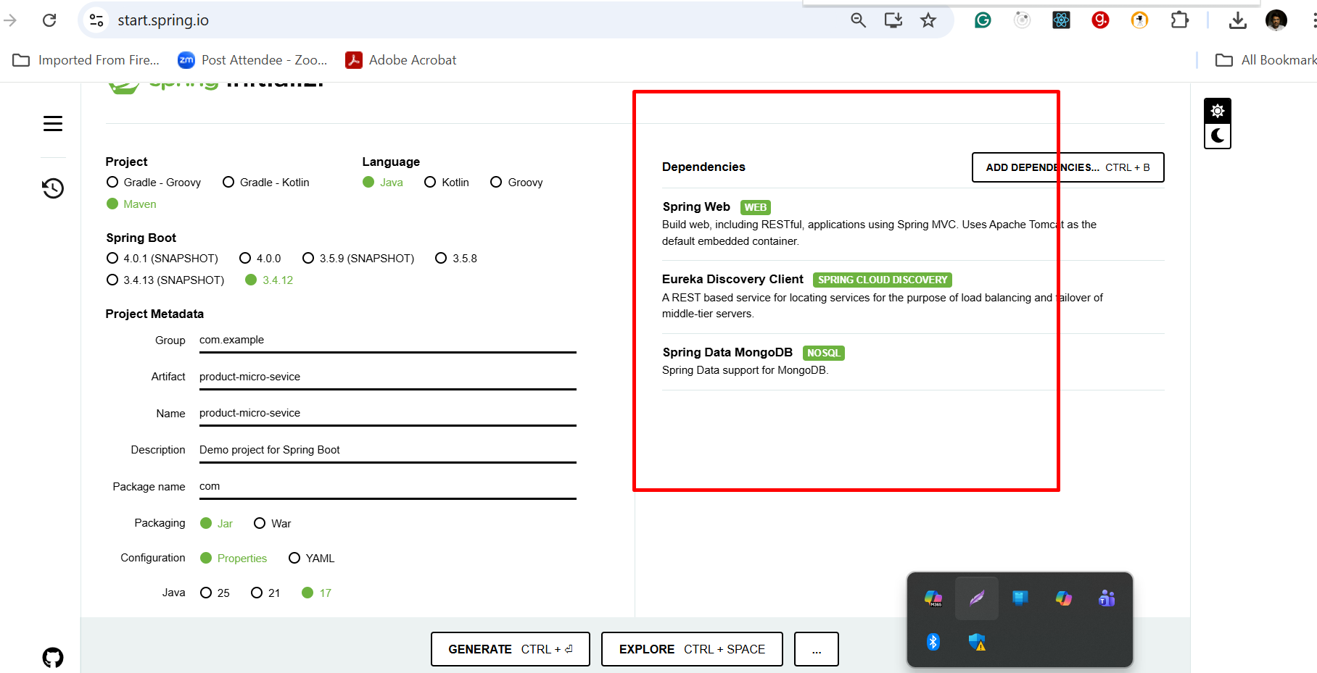

collection class or document class in java side
_id : string
Pname :string
Price : float
Qty : number

5 rest api
post, put/patch, delete, get all or search by id

frontend - product-rest-api-frontend

npm create vite@latest product-rest-api-frontend
cd product-rest-api-frontend
npm install
npm install axios

ES5 style
axios.get()/post()/put()/patch()/delete()
return type is promise object.
then()
catch();

ES6 style
let result = await axios.get(URL); to make code as synchronous
console.log(result);

await() is replacement of then()
await must be inside a function and that function we need to make as async

front end technologies - 5174 (react js)

bridge is browser

backend technologies - 8080 micro service

CORS : Cross Origin Resource Sharing :

In backend side technologies we need to enable CORS policy

useEffect(): this is another hook which get call when component loaded initially. It get call again if any changes happen in dependencies. Mainly use to side effect.
Syntax
useEffect(callback,dependencies)

